| **MN DNR Prescribed Burn Unit Plan** NA-01990-04 | | | | | | | | | | | | | | | | | | | | | | | | | | | | | | | |
| --- | --- | --- | --- | --- | --- | --- | --- | --- | --- | --- | --- | --- | --- | --- | --- | --- | --- | --- | --- | --- | --- | --- | --- | --- | --- | --- | --- | --- | --- | --- | --- |
| **Burn Unit Name and ID:** | | | | | | | | | **Norris Camp JP Slash W1h-098** | | | | | | | | | | | | | | | | | | | | | | |
| County Name | | Lat/Long | | | Sec | | | | Township | | | | Range | | | | Forty | | Management Unit Name  and Number | | | | | | | | | | Administrator | | |
| Lake of the Woods | | 48.60828 and -95.18372 | | | 8 | | | | 159 | | | | 35 | | | | senw | | Beltrami Island State Forest (05) | | | | | | | | | | Forestry | | |
| Burn Unit Description | | | | | | | | | | | | | | | | | | | | | | | | | | | | | | | |
| Fuel Model1 | | | | MN Native Plant Community | | | | | | | | | | Size of Burn (acres)1 | | | | | | | Fuel Loading (tons/acre)1 | | | | | | | | | | |
| 12 (70%) & 11 (30%) | | | | FDn12 | | | | | | | | | | 12 acres | | | | | | | ~20-25 | | | | | | | | | | |
| Additional Burn Unit Descriptors *(e.g. land management goals, overstory/understory, soil, water, other ownerships/administration within burn area, other descriptors (power lines, roads etc))*  The goal of this burn is fire dependent forest plant community enhancement. This is a 2-year-old jack pine cutover site with scattered standing snags and live birch and young balsam fir trees. The slash was scattered rather than piled. | | | | | | | | | | | | | | | | | | | | | | | | | | | | | | | |
| Objectives | | | | | | | | | | | | | | | | | | | | | | | | | | | | | | | |
| *Purpose of burn (measurable treatment objectives):* Reduce 1 hour fuels by 80-90% and 10 hour fuels by 50-60%. Expose mineral soil on 20-40% of the burn area.  *Long term resource objectives:* to enhance the fire-dependant plant community (specifically plants such as blueberries, bearberry, and other ericaceous plants) and help regenerate the site to jack pine or prepare it for planting by removing most of the slash.  *Range of acceptable results: t*o reduce the slash present on the site by approximately 60 - 70%.  *Timing of treatment (in calendar terms and phenological terms):* April – August (some moisture in the soil or green-up in and surrounding the burn area is desired to reduce fire intensity. | | | | | | | | | | | | | | | | | | | | | | | | | | | | | | | |
| Burn Complexity: Use NWCG Complexity Rating Guide (NFES 2474) to Determine Burn Complexity (keep on file) | | | | | | | | | | | | | | | | Low | | | | | | Moderate X | | | | | | High | | | |
| Burn Prescription Window | | | | | | | | | | | | | | | | | | | | | | | | | | | | | | | |
|  | | | | Outputs Prescription Parameters | | | | | | | | | | | | | Guidance Prescription Parameters | | | | | | | | | | | | | | |
| Wind  Direction |  | | | Spread Rate | | | | | | Flame Length | | | | | | | Wind Speed | | | | Temp. | | | Relative Humidity | | 1 Hr Fuel Moisture | | | | 1000 Hr Fuel Moisture or Drought Code | |
| Head | Backing | | | | | | Head | | | Backing | | | 20’ | Mid flame | | |
| S, W, or N | Maximum Prescription | | | 27 ch./hr. | 8 ch./hr. | | | | | | 11’ | | | 3’ | | | Max  15 | Max  10 | | | Max  75 | | | Min  30 | | 8 | | | | >20% | |
| Minimum Prescription | | | 8 ch./hr. | 1 ch./hr. | | | | | | 6’ | | | 1’ | | | Min  5 | Min  5 | | | Min  45 | | | Max  70 | | 20 | | | | N/A | |
| Additional Considerations | | | | | | | | | | | | | | | | | | | | | | | | | | | | | | | |
| Consideration | | | | | | | | Mitigation | | | | | | | | | | | | | | | | | | | | | | | |
| Cultural site(s): None | | | | | | | |  | | | | | | | | | | | | | | | | | | | | | | | |
| Natural Heritage Elements: None | | | | | | | |  | | | | | | | | | | | | | | | | | | | | | | | |
| Adjacent Land Concerns: Yes | | | | | | | | Norris Camp, dozer and equipment will be placed to protect it. | | | | | | | | | | | | | | | | | | | | | | | |
| Peat Soils or Wet Soils: No | | | | | | | |  | | | | | | | | | | | | | | | | | | | | | | | |
| Other: some poison ivy along east side | | | | | | | | Face masks will be used when working in this area. Plants will be grubbed out before burn and removed. | | | | | | | | | | | | | | | | | | | | | | | |
|  | | | | | | | |  | | | | | | | | | | | | | | | | | | | | | | | |
| **Emergency Telephone Numbers** | | | | | | | | | | | | | | | | | | | | **Burn Activity Contacts** | | | | | | | | | | | |
| Forestry - Williams | | | | | | | 218-783-6935 | | | | | | | | | | | | |  | | | | | | |  | | | | |
| Fire Dept - Williams | | | | | | | 783-4601 | | | | | | | | | | | | |  | | | | | | |  | | | | |
| Sheriff - Baudette | | | | | | | 634-1143 | | | | | | | | | | | | |  | | | | | | |  | | | | |
| Medical – Warroad Ambulance | | | | | | | 911 (ask for Warroad ambulance) | | | | | | | | | | | | |  | | | | | | |  | | | | |
|  | | | | | | |  | | | | | | | | | | | | |  | | | | | | |  | | | | |
| Personnel Needs | | | | | | | | | | | | | | | | | | | | | | | | | | | | | | | |
| Burn Boss Level (Note: tied to the burn complexity level): | | | | | | | | | | | | | | | 2 | | | | | | | | | | | | | | | | |
| Number Needed | | | Position | | | | | | | | | | | | | | | | | | Names(Optional) | | | | | | | | | | |
| 2  5 | | | Ignition Specialists  Holding Crew | | | | | | | | | | | | | | | | | |  | | | | | | | | | | |
| Equipment Needs | | | | | | | | | | | | | | | | | | | | | | | | | | | | | | | |
| Number needed | | | Equipment Type | | | | | | | | | | | | | | | | | | Source | | | | | | | | | | |
| 1  2  1  1 | | | Engine  Tracked Vehicles (J-8 or J-5, SkidSteer, or equivalent)  ATV with slip-on unit  Dozer (D-7) | | | | | | | | | | | | | | | | | | Norris Camp  Wannaska/Williams Forestry or Norris Camp  Norris Camp  Norris Camp | | | | | | | | | | |
| Operations Plans | | | | | | | | | | | | | | | | | | | | | | | | | | | | | | | |
| Pre-burn Site Preparation Plan: A dozed firebreak will be put in along the west side of the burn area between the cutover area to be burned and the young jack pine to the west. A disked break will be put in along the grass field on the northwest side. | | | | | | | | | | | | | | | | | | | | | | | | | | | | | | | |
| Ignition/Firing Plan: (Include provisions for a test fire, firing pattern, firing device, preferred wind direction, hazards/special considerations): A test fire will be set in the slash along the northeast or southeast part of the burn unit to see if fire behavior matches what is predicted. The preferred wind directions are NW or SW. The tracked vehicle (J-5 or J-8 or positrack) will be present to extinguish the test fire if the behavior observed is outside of the prescription. Firing will consist of sequential strip headfires to be lit at about 10-20 foot intervals. | | | | | | | | | | | | | | | | | | | | | | | | | | | | | | | |
| Holding Plan: (Staging area, holding lines, resources and positions): The dozer will be stationed near the northeast corner of the burn to respond to any spots outside of the burn area that need a break put around them. The tracked vehicle will be stationed along the west firebreak to respond to any spots in the young jack pine west or south of the burn. The engine and ATV will be stationed on the roads next to the burn to respond to any spots adjacent to the roads. | | | | | | | | | | | | | | | | | | | | | | | | | | | | | | | |
| Patrol/Mop-up Plan: (Mopup instructions, safety concerns, weather, contingency, rehab, patrol instructions): The dozer will be used where needed to break up smoldering piles. The J-8 (or J-5 or Positrack) will be used to access the area. A crew of 2 to 3 people will stay to mop up until everything within 100 feet of the perimeter of the burn is extinguished and until there are no open flames present. Small areas greater than 100 feet in to the burn may be allowed to smolder overnight and will be mopped up the following day. | | | | | | | | | | | | | | | | | | | | | | | | | | | | | | | |
| Contingency Plans | | | | | | | | | | | | | | | | | | | | | | | | | | | | | | | |
| (Include secondary control lines, termination of ignition procedures, list of contingency resources and approximate response times, trigger points, backup plan for equipment failure etc.): Secondary control lines are the Norris Camp driveways and the Airport Road to the northeast, the Airport Road, the Airstrip, and an old timber access road to the east. The Faunce-Butterfield Road and the Firebreak Road are secondary control lines to the west and south.  Any spots will be immediately extinguished using available resources - firing will be suspended until the spot is under control. Extra water is located at Norris Camp.  If an escape cannot be handled with available resources, the Warroad/Wannaska Forestry office will be called to provide additional resources or the Thief Lake/Roseau River WMA crew and equipment will be called in if Forestry is unavailable. The response time for the Forestry offices is about 1 hour. Response times for Thief Lake or Roseau River is about 1.5 hours. | | | | | | | | | | | | | | | | | | | | | | | | | | | | | | | |
| Smoke Management Plan[1] | | | | | | | | | | | | | | | | | | | | | | | | | | | | | | | |
| Smoke Dispersion Category (should be fair or better to burn)1: Fair to Excellent. | | | | | | | | | | | | | | | | | | | | | | | | | | | | | | | |
| Distance and Direction from Smoke Sensitive Area(s)1: Norris Camp and the Faunce-Butterfield Roads are immediately north of the burn unit. | | | | | | | | | | | | | | | | | | | | | | | | | | | | | | | |
| Smoke Management Plan (Describe how you intend to mitigate the effects of smoke on roads, firefighters, neighbors and other sensitive receptors. Include safety considerations)1: If the burn is conducted with a southwest wind, Norris Camp will be evacuated during the burn and staff from the Camp not working on the burn (office manager, grouse researchers, conservation officer) will be placed along the Faunce-Butterfield Road to alert passersby to the prescribed burn and to use caution while traveling along the road.  It will be important for people working on this fire to be aware of their exposure to smoke and to rotate out of downwind areas at regular intervals. They should also wear smoke masks whenever working in the smoke. The burn boss and ignition specialists will need to be aware of this and ensure that people are rotated out of the smoke. | | | | | | | | | | | | | | | | | | | | | | | | | | | | | | | |
| Safety Plan | | | | | | | | | | | | | | | | | | | | | | | | | | | | | | | |
| Identify safety zones, escape routes, communications plan:  Safety zones for this fire will be Norris Camp if it’s with a NW wind or the Air Field if it’s with a SW wind. After ignition commences the black will serve as an additional safety zone in areas that are not immediately near any burning snags. Escape routes include fire breaks including the Airport and Faunce-Butterfield Roads.  Communication on the burn will be on DNR tactical channel 2. Telephone communication will also be available from Norris Camp, however it will be for emergencies only and will not be a primary means of communication. | | | | | | | | | | | | | | | | | | | | | | | | | | | | | | | |
| Medical Plan | | | | | | | | | | | | | | | | | | | | | | | | | | | | | | | |
| (In addition to notification of 9-1-1 dispatcher, identify nearest ground and air ambulance service, availability of paramedics, location of nearest hospital and list what first aid supplies are available at the burn site and what person or equipment they are assigned to):  The nearest ground ambulance is located in Warroad. All members of the burn crew are trained in first aid. A first aid kit will be on site in the engine. | | | | | | | | | | | | | | | | | | | | | | | | | | | | | | | |
| List of Attachments | | | | | | | | | | | | | | | | | | | | | | | | | | | | | | | |
| Project Map | | | | | | X | | | | | Fire Behavior Calculations (optional) | | | | | | | | | |  | |  | | | | | | | |  |
| Permission to Burn on non-DNR Land | | | | | |  | | | | | Road Control Plan (optional) | | | | | | | | | |  | |  | | | | | | | |  |
| Risk/Safety Assessment (optional) | | | | | |  | | | | | Organization Chart (optional) | | | | | | | | | |  | |  | | | | | | | |  |
| Signatures | | | | | | | | | | | | | | | | | | | | | | | | | | | | | | | |
| Prepared by: Gretchen Mehmel | | | | | | | | | | | | Qualification Title: RxB2 | | | | | | | | | | | | | Date: 2/28/2010 | | | | | | |
| Reviewed by[2]2: | | | | | | | | | | | | Qualification Title: | | | | | | | | | | | | | Date: | | | | | | |
| Reviewed by[3]3: | | | | | | | | | | | | Title: | | | | | | | | | | | | | Date: | | | | | | |
| Approved by[4]3: | | | | | | | | | | | | Title: | | | | | | | | | | | | | Date: | | | | | | |

|  |  |  |  |  |
| --- | --- | --- | --- | --- |
| **MN DNR Prescribed Burn Unit Plan** NA-01990-04 | | | | |
| **Burn Unit Name and ID:** | |  | | |
| Go/No Go Checklist | | | | |
|  | ALL burn prescription elements met. | |  | ALL personnel have the required PPE with them. |
|  | ALL smoke management specifications met. | |  | ALL pre-burn considerations (line preparation) identified in the plan addressed. |
|  | ALL current and projected fire weather forecasts have been obtained and are favorable. | |  | ALL the required notifications been made.  (landowners, media, cooperators, sheriff etc) |
|  | ALL planned operations personnel and equipment on-site, available and operational. | |  | ALL permits and approvals been obtained.  (open burning permit, Non-DNR land permission) |
|  | APPROPRIATE contingency resources have been confirmed and are available | |  | ALL on-site holding forces adequate for containment under the expected conditions. |
|  | ALL personnel briefed on the burn objectives, their assignment, safety hazards, escape routes, communications and contingency plans. | |  | Burn Boss believes the burn can be carried out according to the Prescribed Burn Unit Plan and will meet the planned objectives. |

|  |  |  |  |  |  |  |
| --- | --- | --- | --- | --- | --- | --- |
| Prescribed Burn Unit Report | | | | | | |
| Weather | | | | | | |
|  | Time | Wind Direction | Wind Speed | Temperature | Relative Humidity | Comment |
| Forecasted Fire Weather |  |  |  |  |  |  |
| Spot weather forecast |  |  |  |  |  |  |
| Observed weather |  |  |  |  |  |  |
|  |  |  |  |  |  |  |
|  |  |  |  |  |  |  |
|  |  |  |  |  |  |  |
|  |  |  |  |  |  |  |

|  |  |  |  |  |  |  |  |  |
| --- | --- | --- | --- | --- | --- | --- | --- | --- |
| Observed Fire Behavior | | | |  | Acres Burned by Cover Type | | | |
| Time | Spread Rate | Flame Lengths | Scorch Height | Fuel Model | Completed Acres | ECS Type Sub Type | Completed Acres |
|  |  |  |  |  |  |  |  |
|  |  |  |  |  |  |  |  |
|  |  |  |  |  |  |  |  |
|  |  |  |  |  |  |  |  |
|  |  |  |  |  |  |  |  |
|  |  |  |  |  |  |  |  |

|  |  |  |
| --- | --- | --- |
| Post Burn Observations | | |
|  | | |
| Recommendations | | |
|  | | |
| Burn Boss Signature | | |
| Name: | Title: | Date: |

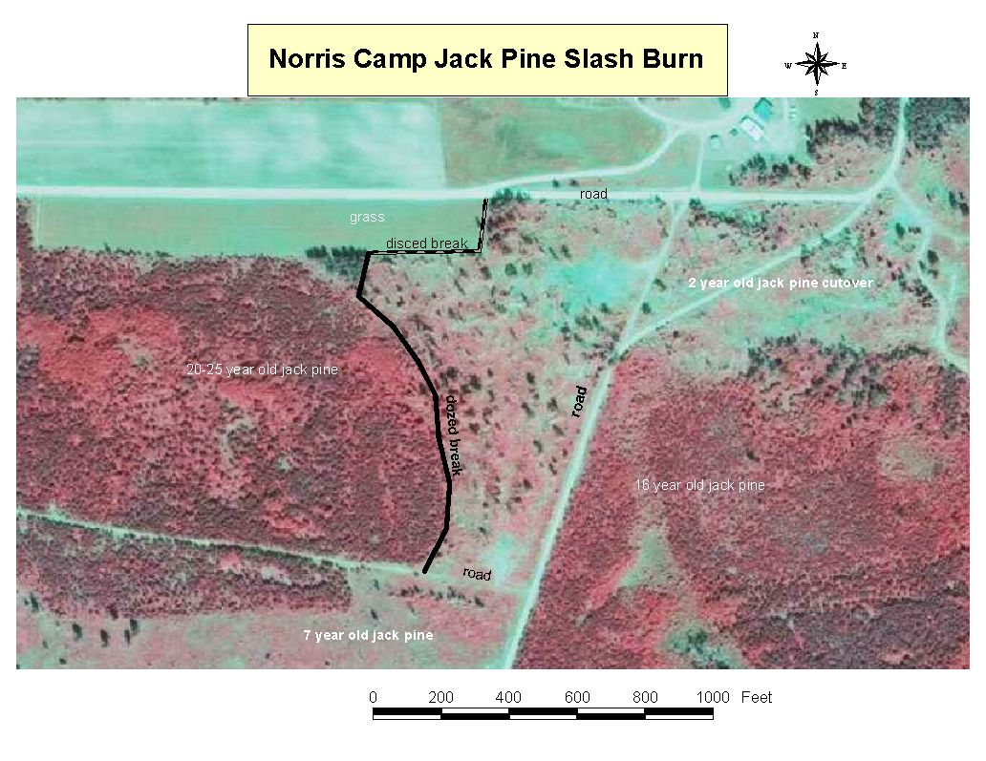

1. Required for MN Pollution Control Agency reporting requirements
2. 2 All burn plans must be reviewed and signed by a qualified Burn Boss 1 or 2 as specified by Commissioner’s Operational Order 47
3. 3 As per Division policy
4.